Monday January 9th  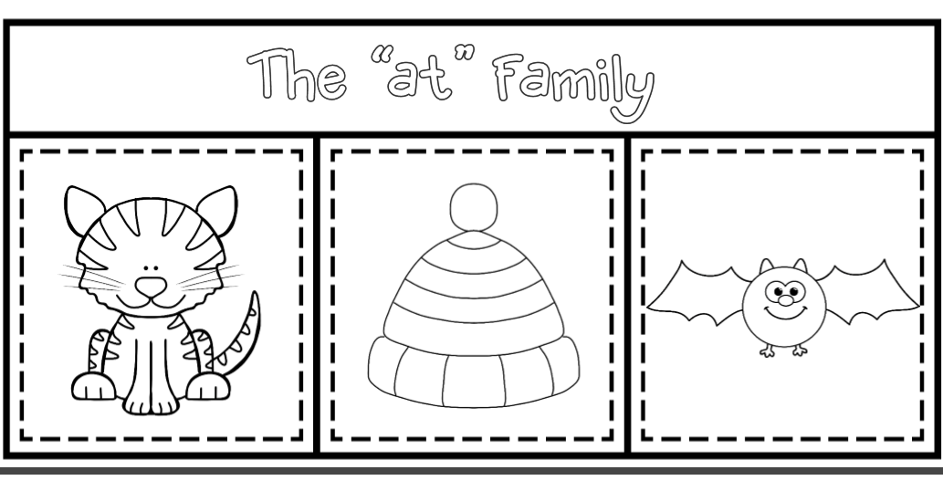  ELA: Write the word on the line to match the picture.  ______ ______ ______  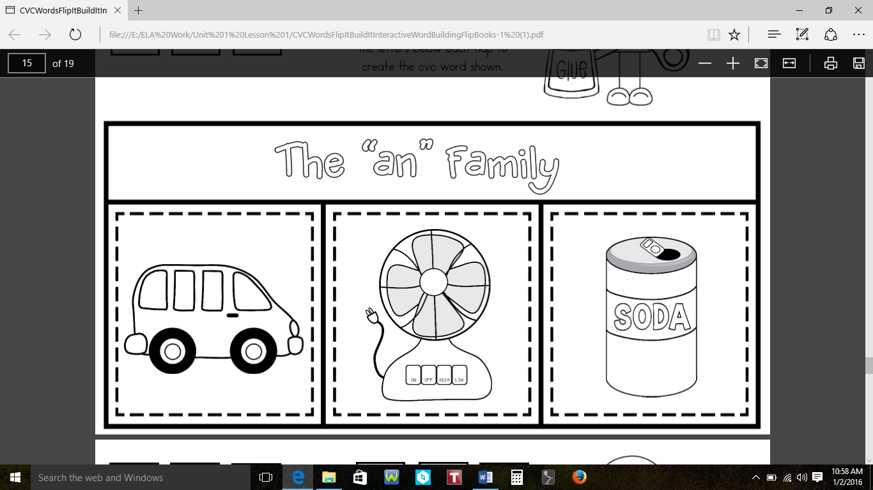  ______ ______ ______  Math: Count to 75. How far did you count? _________  Parent’s Initials: _________ | Tuesday, January 10th  ELA: Write each word three times each.  them____________________________________________  play_____________________________________________  give____________________________________  Math:  1. Draw a ribbon that is longer than the ribbon in number 1.  2. Draw a ribbon that is shorter than the ribbon in number 2.  3. Draw a ribbon that is the same length as the ribbon in number 3.  Parent’s Initials: __________
Wednesday, January 11th  ELA: Unscramble the words to make a sentence. Write the sentence on the line.  1. sat Tam on mat the Cat.  ____________________________  ____________________________  2. can Tam Cat Pam pat.  ____________________________  ____________________________  Math: Circle the object that is heavier. Mark an X on the object that is lighter.  Parent’s Initials: ____________________ | Thursday, January 12th  ELA: Write the missing letter to spell the word.  Math: Circle the object that holds more.  Circle the object that holds less.  Parent’s Initials: ____________________

