Monday, February 27th  ELA: Write each word three times each.  there__________________  ______________________  by____________________  ______________________  do____________________  ______________________  Math: Solve the subtraction problems  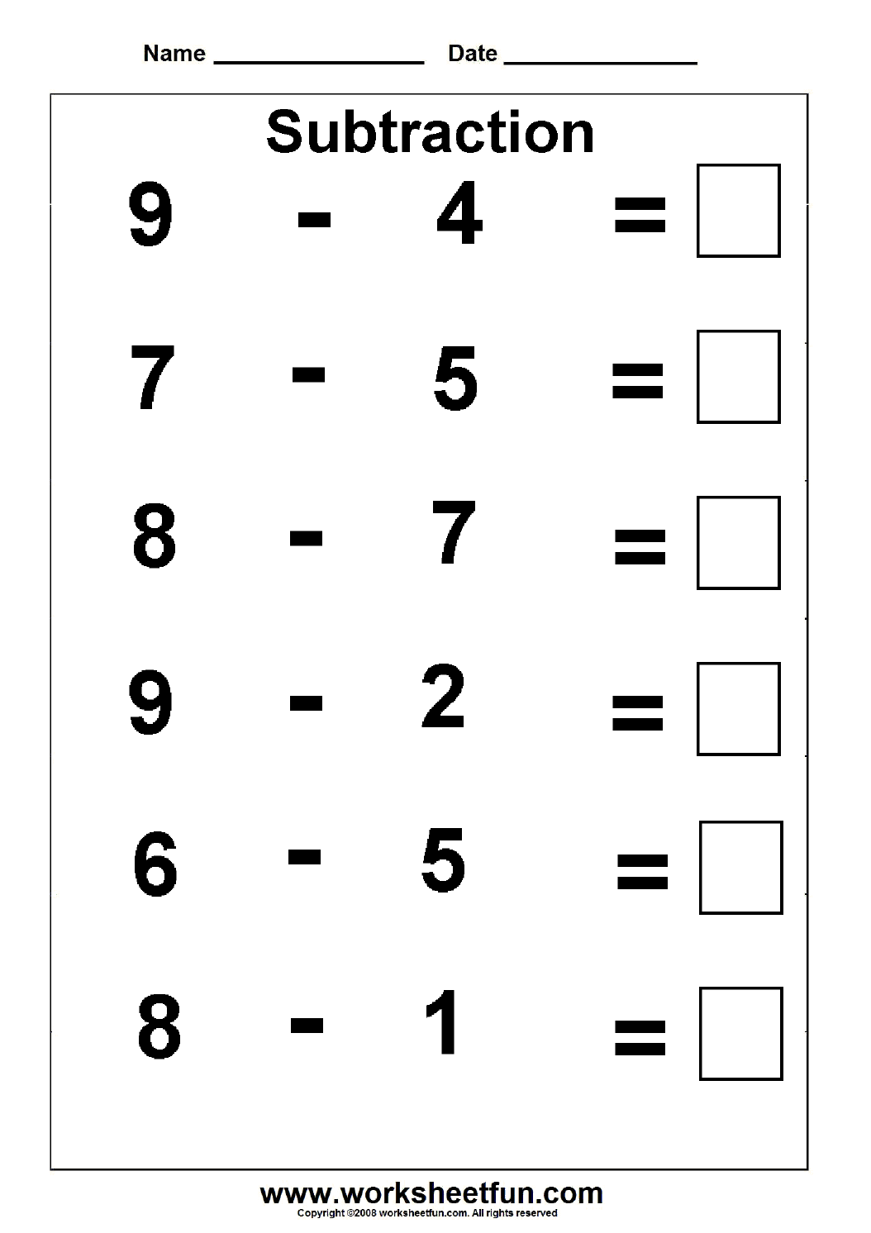  Parent’s Initials: __________________ | Tuesday, February 28th  ELA: Use each past-tense verb in a sentence.  saw watched ran  1._____________________________  _______________________________  2._____________________________  _______________________________  3._____________________________  _______________________________  Math: Complete the number sentence and the number bond.  Parent’s Initials: _________________

Wednesday, March 1st  ELA: Draw a line to match the word on the left to the synonym on the right (A synonym is a word that means the same).  present  home  paste  little  unhappy  insect  happy  huge  Math: Solve the subtraction problem.  Parent’s Initials ______________________ | Thursday, March 2nd  ELA: Write the numbers in the boxes (1-4) to put the story in order. 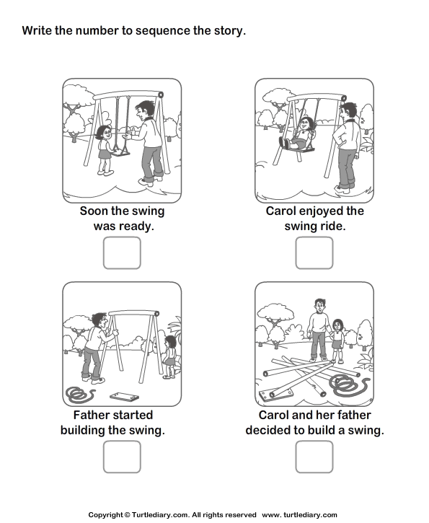  Math:  Solve the subtraction problems.  Parent’s Initials: ______________

